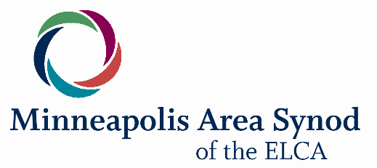

Day by day … they ate their food with glad and generous hearts, praising God and having the good will of all the people. – Acts 2:46-47

Grace, peace, and hope through our Savior, Jesus Christ.
In May, we meet for our 2024 Synod Assembly under the theme “With Glad and Generous Hearts.” The phrase describes the early church as they gathered on
Pentecost. It is also an appropriate description of the past year of our life and
ministry together.
In 2023, our hearts were gladdened by:
- Your congregation, along with the other 136 congregations in our synod,
faithfully proclaiming the Gospel of Jesus Christ in Word and Sacrament,
nurturing community, and loving neighbors and neighborhoods.
- The privilege of accompanying congregations in 72 Call Processes; presiding
at 14 Ordinations and 30 Installations; and walking with 34 people preparing
to become pastors or deacons.
- 142 lay leaders and 28 clergy from 31 congregations learning to be church in
the 21st century through our Faith Practices and Neighboring Practices
intensive learning communities.
- 6,500 people receiving our weekly enews. (Sign up at mpls-synod.org/sign-up
to feel more connected.)
- 100s of rostered and lay leaders involved in synod sponsored peer groups, conferences, and retreats.
- 100s of leaders from synod congregations helping pass the state’s “100% Clean Energy By 2040” and “Restore The Vote” legislation that advance both climate justice and racial justice.
- 100s of leaders faithfully serving as Deans, on Synod Council, and Candidacy, Audit, Program Committees.
- 15 gifted and devoted synod staff members: 10 funded by Mission Support
from you and other congregations, and 5 funded by Lilly Endowment and other external grants.

We praise God for the congregational generosity that makes all this happen. At the same time, we recognize that mission support from congregations has declined 16% over the past 10 years, resulting in a reduction in synod staff hours. Especially as we prepare to elect a new bishop this spring, we invite you to consider strengthening your support for the future of the synod’s work.

Conference Assemblies are just around the corner: Saturday, February 10, 9:30 a.m. – Noon. Of particular importance will be conference nominations for bishop as well as for voting members to the ELCA Churchwide Assembly, July 28 - August 2, 2025. We encourage congregations to send the same voting members to both the Conference and
Synod Assemblies.

As we look at declining mission support or grieve the closing of a congregation, we can become discouraged. In such moments, I encourage you to listen to a remarkable conversation from our 2023 Synod Assembly. Our keynote speaker, the Rev. Otis Moss III, was asked: “what do you say to those who think the church is dying?” Filled with courage and hope, Moss responded, “the church is not dying, it is being born, refashioned, and remade. The early church was an alternative community. Today we use the metrics of the market to evaluate the church – buildings, budgets, numbers. But, the early church looked at impact: were people hearing the good news of Jesus who lived and died for our salvation? Was suffering being relieved? Were people being welcomed and healed?” (mpls-synod.org/our-synod/synod-assembly-2/2023-synod-assembly-archives 4:57:27 of the second day)

Rev. Moss reminds us that we are called to be alternative communities. What might it take to measure our churches by impact? The work of synod leadership is to support the 137 communities and the thousands of leaders who are making an impactful difference in the 21st century: sharing the good news of Jesus, extending radical welcome into beloved community, engaging their neighborhoods in love with justice.

I am filled with both gratitude and sadness as I write this, my final annual report to congregations. I have loved serving as your bishop and am profoundly grateful for this calling. We pray for the year ahead, trusting in the goodness and faithfulness of our God, made known in Jesus Christ.
Bishop Ann Svennungsen

