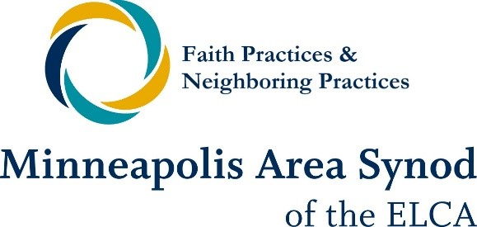

Faith Practices & Neighboring Practices: Renewing Congregational Imagination is a two-year learning community for congregations in the Minneapolis Area Synod. We believe that vital congregations take seriously the small simple practices that build community, cultivate mutual relationships, and expand our awareness of God’s activity in the places where we have been called to live.
The 2nd Faith Practices & Neighboring Practices learning community launches in Fall 2023. Applications are now open for congregations interested in learning what it looks like to be faithful neighbors in your context. If your congregation is interested, please have a pastor and lay member complete the application form on the synod website. Our Faith Practices & Neighboring Practices team will follow up to schedule a conversation where we can dig into the application questions more deeply. If you have any questions, please contact a member of the team.
mpls-synod.org/for-congregations/faith-neighboring

